Name

Mathematics Stage 5 Paths
Equations with
Algebraic Fractions

Book 1 |  | Version: 261002  Feedback:  https://MrDingMaths.com
Contents
Syllabus Content 2
Learning Intention 3

Syllabus Content
MA5-EQU-P-02 solves linear equations of more than 3 steps, monic and non-monic quadratic equations, and linear simultaneous equations
Solve linear equations involving algebraic fractions and equations of more than 3 steps
- Solve linear equations involving more than 3 steps
- Solve equations that involve 2 or more fractions

Algebraic Fractions: Monomial Numerators

- Equations involving Algebraic Fractions: Monomial Numerator
- To solve equations involving two algebraic fractions:
- Rewrite each algebraic fraction with their common denominator.
- Simplify by adding or subtracting the fractions.
- Solve.

- Example Solve equations involving two fractions and monomial numerators
$$\frac{x}{2}+\frac{x}{5}=3$$1. Denominators $\frac{5x}{10}$ $+$ $\frac{2x}{10}$ $=3$2. Simplify $\frac{7x}{10}$ $=3$3. Solve $×10=×10$ $7x=30$ $÷7=÷7$ $x=$ $\frac{30}{7}$

- Guided Practice
Solve these equations.
- $\frac{x}{5}+\frac{2x}{5}$ $=18$  $$x=30$$ | - $\frac{x}{5}+\frac{x}{6}$ $=22$  $$\frac{}{30}+\frac{}{30}=22$$  $$x=60$$
- $\frac{2x}{3}+\frac{5x}{4}$ $=46$  $$x=24$$ | - $\frac{x}{3}-\frac{x}{2}$ $=10$  $x=-60$

Foundation
- Solve these equations by making the denominators the same.
- $\frac{x}{5}+\frac{x}{2}$ $=21$  $\frac{2x}{10}+\frac{5x}{10}$ $=21$  $$30$$ | - $\frac{x}{2}-\frac{x}{5}$ $=-12$  $$-40$$ | - $-\frac{x}{4}+\frac{x}{3}$ $=-5$  $$-60$$
- $-\frac{x}{2}-\frac{x}{3}$ $=-5$  $$6$$ | - $\frac{3x}{2}+\frac{7x}{5}$ $=5$  $$\frac{50}{29}$$ | - $\frac{5x}{6}-\frac{3x}{7}$ $=-2$  $$-\frac{84}{17}$$
- $\frac{x}{2}+\frac{2x}{3}$ $=$ $7$  $$6$$ | - $\frac{x}{4}+\frac{3x}{3}$ $=5$  $$4$$ | - $\frac{3x}{5}-\frac{2x}{3}$ $=1$  $$-15$$
- $\frac{2x}{3}+\frac{5x}{4}$ $=46$  $$24$$ | - $\frac{x}{5}+\frac{x}{6}$ $=22$  $$60$$ | - $10=$ $\frac{x}{2}+\frac{x}{3}$  $$12$$
- $4=$ $\frac{x}{2}-\frac{x}{3}$  $$24$$ | - $\frac{6x}{5}+\frac{2x}{3}$ $=28$  $$15$$ | - $4=$ $\frac{3x}{7}-\frac{x}{3}$  $$42$$

Development
- Half of a number ($x$) plus one-third of twice the same number is equal to 4.
  - Write an equation describing the situation.
  - Solve the equation to find the number.

$$\frac{x}{2}+\frac{2x}{3}=4$$
$$x=\frac{24}{7}$$
- Mila and Sophie each have the same number of computer games ($x$ computer games each). Rachel, who doesn’t have any games, takes one-third of Mila’s computer games and a quarter of Sophie’s computer games to give her a total of 77 computer games.
  - Write an equation describing the total number of computer games for Rachel.
  - Solve the equation to find how many computer games Mila and Sophie each had.

$$\frac{x}{3}+\frac{x}{4}=77$$
$$x=132$$
- Sookai drove to her holiday destination 1000 km away over a period of five days.
on the first day she travels a certain distance,
on the second day she travels half that distance,
on the third day a third of that distance,
on the fourth day one-quarter of the distance and
on the fifth day one-fifth of the distance and reached her destination.
Write an equation and solve it to find how far she travelled on the first day, to the nearest kilometre.

$$x+\frac{x}{2}+\frac{x}{3}+\frac{x}{4}+\frac{x}{5}=1000$$
$x=438$ km
- If two-thirds of a number is subtracted from three-quarters of the number, the result is 6.
Find the number.

$$\frac{3x}{4}-\frac{2x}{3}=6$$
multiply by 12
$$9x-8x=72$$
$x=72$
- One-quarter of a number, plus one-third of a number, is the same as subtracting 10 from the number. Find the number.

$$\frac{x}{4}+\frac{x}{3}=x-10$$
multiply by 12
$7x=12x-120$
$5x=120$
$x=24$
- When a certain number is divided by 3, the result is the same as when half of the number is decreased by 2. Find the number.

$$\frac{x}{3}=\frac{x}{2}-2$$
multiply by 6
$$2x=3x-12$$
$x=12$
- I bought two trays of mangoes. In the first tray a quarter were bad.
In the second tray, which contained four less mangoes, only a fifth were bad.
If I had a total of 34 good mangoes, how many mangoes were there in each tray?
Let first tray have $k$ mangoes, second tray has $k-4$.
$$\frac{3}{4}k+\frac{4}{5}(k-4)=34$$
multiply by 20: $15k+16(k-4)=680$
$31k=744$, $k=24$.
First tray: 24 mangoes, second tray: 20 mangoes.

- Jenny is 5 and Micah is 12. When will Jenny be half Micah’s age?
Let this happen in $x$ years.
$$5+x=\frac{1}{2}(12+x)$$
multiply by 2:
$10+2x=12+x$, $x=2$.
In 2 years.

Algebraic Fractions: Binomial Numerators

- Equations involving Algebraic Fractions: Binomial Numerator
- To solve equations involving two algebraic fractions with binomial numerators:
- Rewrite each algebraic fraction with their common denominator.
If the fraction has a binomial numerator, you must multiply each term.
- Simplify by adding or subtracting the fractions.
- Solve.

- Example Solve equations involving two fractions and binomial numerators
$$\frac{x-1}{2}+\frac{x+2}{5}=2$$
1. Denominators $\frac{5\left(x-1\right)}{10}$ $+$ $\frac{2\left(x+2\right)}{10}$ $=2$2. Simplify $\frac{5x-5+2x+4}{10}$ $=2$ $\frac{7x-1}{10}$ $=2$3. Solve $×10 ×10$ $7x-1=20$ $7x=21$ $x=3$

- Guided Practice
Solve these equations.
- $\frac{x+3}{3}+\frac{x-4}{2}$ $=4$  $$\frac{2(x+3)}{6}+\frac{3(x-4)}{6}=4$$  $$x=6$$ | - $\frac{x-1}{3}=\frac{x}{4}$  $$x=4$$
- $\frac{x}{2}-\frac{2x+1}{3}$ $=2$  $$x=-14$$ | - $\frac{x+2}{3}-\frac{2x-1}{2}$ $=4$  $$x=-\frac{17}{4}$$

Foundation
- Solve these equations.
- $\frac{3x}{2}-\frac{x}{8}$ $=12$  $$\frac{96}{11}$$ | - $\frac{x}{3}+\frac{2x-1}{4}$ $=0$  $$\frac{3}{10}$$ | - $\frac{x}{4}+\frac{2x+1}{6}$ $=0$  $$-\frac{2}{7}$$
- $\frac{x+3}{2}+\frac{x-4}{3}$ $=1$  $$1$$ | - $\frac{x+2}{3}+\frac{x-1}{2}$ $=1$  $$1$$ | - $\frac{x-4}{5}+\frac{x+2}{3}$ $=2$  $$4$$

- Read the example carefully and answer the questions.
Worked Solution | Explanation
Solve:  $$\frac{2x}{3}-\frac{x-5}{5}=3 \\ \frac{5(2x)}{15}-\frac{3(x-5)}{15}=3 \\ \frac{5(2x)-3(x-5)}{15}=3 \\ \frac{7x+15}{15}=3 \\ ×15=×15 \\ 7x-15=45 \\ 7x=60 \\ x=\frac{60}{7}$$ | In the step marked by the arrow, why is it important we have brackets?  We are subtracting ………… of the fraction, so we need ……………… to group the terms together.  By expanding and simplifying, show why the numerator is $7x+15$.

Development
- Solve these equations.
- $\frac{x+2}{3}-\frac{x-1}{2}$ $=1$  1 | - $\frac{x-4}{5}-\frac{x+2}{3}$ $=2$  $$-26$$ | - $\frac{x+1}{5}-\frac{x+1}{6}$ $=2$  59
- $\frac{x+5}{2}-\frac{x-1}{4}$ $=3$  1 | - $\frac{2y-1}{4}-\frac{y-2}{6}$ $=-1$  $$-\frac{13}{4}$$ | - $\frac{2x+3}{4}-\frac{7x-1}{6}$ $=2$  $$-\frac{13}{8}$$

- Solve these equations.
- $3\left(x+3\right)=6x$  3 | - $\frac{x+3}{3}$ $=6x$  $$\frac{3}{17}$$
- $\frac{x+3}{3}+\frac{x+3}{6}$ $=6x$  $$\frac{3}{11}$$ | - $\frac{x+3}{3}-\frac{x+3}{6}$ $=6x$  $$\frac{3}{35}$$

- Solve these equations.
- $\frac{x+2}{2}+\frac{x+4}{3}$ $=4$  $$2$$ | - $\frac{x+2}{6}-\frac{x+4}{8}$ $=9$  $$220$$ | - $\frac{4x-2}{6}-\frac{4x-4}{8}$ $=9$  $$53$$
- $\frac{x+2}{2}+\frac{x+4}{8}$ $=4$  $$4$$ | - $\frac{x+2}{6}-\frac{x-4}{8}$ $=9$  $$196$$ | - $\frac{4x-4}{8}-\frac{4x-2}{6}$ $=9$  $$-55$$
- $\frac{x+2}{2}+\frac{x+4}{8}$ $=9$  $$12$$ | - $\frac{x-2}{6}-\frac{x-4}{8}$ $=9$  $$212$$ | - $\frac{4x-4}{8}-\frac{4x-2}{6}$ $=1$  $$-7$$
- $\frac{x+2}{6}+\frac{x+4}{8}$ $=9$  $$28$$ | - $\frac{2x-2}{6}-\frac{2x-4}{8}$ $=9$  $$106$$ | - $\frac{4x-4}{8}-\frac{4x-2}{6}=\frac{1}{2}$  $$-4$$
- 2013 HSC Standard 2 Band 5
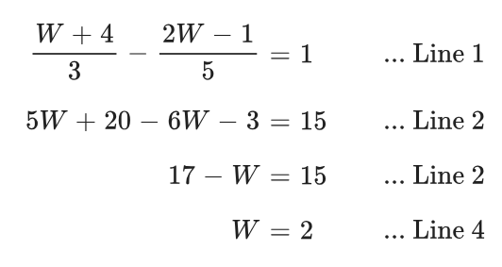
Mr Ding tried to solve this equation and made a mistake in Line 2.

Solve this equation correctly for $W$.
$$\frac{W+4}{3}-\frac{2W-1}{5}=1$$

$$w=8$$
- Solve these equations
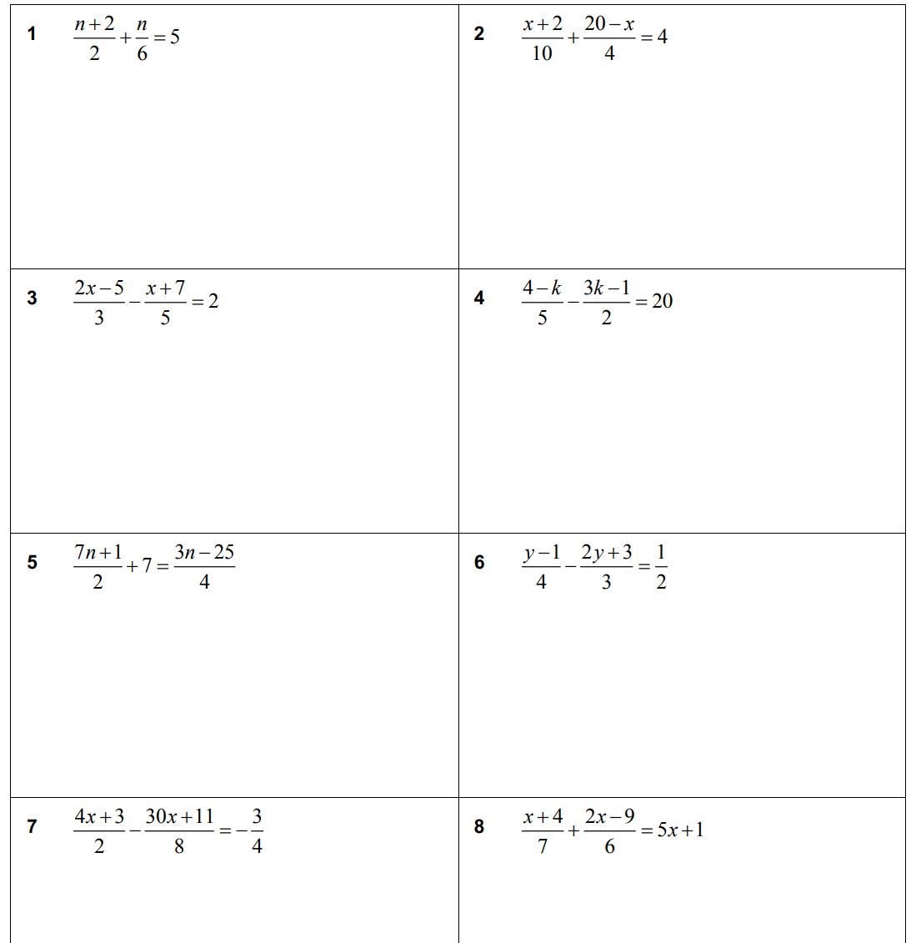  6 | 8 | $$\frac{76}{7}$$
$$-11$$ | $$\frac{1}{2}$$ | $$-\frac{21}{5}$$

- Solve these equations.
$$\frac{x+1}{2}-\frac{x}{3}+\frac{4x}{5}=-1$$  $$-\frac{45}{29}$$ | $$\frac{4-2x}{3}-\frac{5x}{4}+\frac{3x+1}{2}=2$$  $$-\frac{2}{5}$$

- Solve these equations.
- $\frac{6x-5}{4}-\frac{7-8x}{3}$ $=$ $\frac{1}{2}$  $$\frac{49}{50}$$ | - $\frac{a-10}{5}-\frac{5-2a}{4}$ $=$ $\frac{1}{2}$  $$\frac{75}{14}$$ | - $\frac{2x-7}{3}-\frac{5-4x}{2}$ $=$ $\frac{2}{5}$  $$\frac{157}{80}$$

Algebraic Fractions: Cross Multiplying

- Cross Multiplying
- Cross multiplying is a shortcut.
- Only use this shortcut when $Fraction=Fraction$

$$\frac{a}{b}=\frac{c}{d}$$
$$\frac{a}{b}=\frac{c}{d}$$
$$ad=bc$$

- Example Solve equations involving fractions by cross multiplying
Common denominator method | Cross multiplying method
$$\frac{x-1}{3}=\frac{x}{4} \\ \frac{4\left(x-1\right)}{12}=\frac{3x}{12} \\ ×12=×12 \\ 4\left(x-1\right)=3x \\ 4x-4=3x \\ -3x=-3x \\ x-4=0 \\ +4=+4 \\ x=4$$ | $$\frac{x-1}{3}=\frac{x}{4}$$  cross multiply  $$4\left(x-1\right)=3x \\ 4x-4=3x \\ -3x=-3x \\ x-4=0 \\ +4=+4 \\ x=4$$

- Guided Practice
Solve these equations.
- $\frac{x+2}{5}=\frac{x}{3}$  $$x=3$$ | - $\frac{x+1}{2}=\frac{x}{3}$  $$x=-3$$ | - $\frac{3x-1}{5}=\frac{2x}{7}$  $$x=\frac{7}{11}$$
- $\frac{x-1}{2}=\frac{x+1}{4}$  $$x=3$$ | - $\frac{2y-1}{5}=\frac{y+1}{4}$  $$y=3$$ | - $\frac{3+y}{2}=\frac{2-y}{3}$  $$y=-1$$

Foundation
- Solve these equations.
- $\frac{x+1}{4}=\frac{x}{3}$  $$3$$ | - $\frac{2x-1}{6}=\frac{3x}{5}$  $$-\frac{5}{8}$$ | - $\frac{x-2}{3}=\frac{x}{2}$  $$-4$$
- $\frac{x+3}{4}=\frac{x-1}{2}$  $$5$$ | - $\frac{x+2}{3}=\frac{x+1}{2}$  $$1$$ | - $\frac{3+x}{2}=\frac{2-x}{3}$  $$-1$$
- $\frac{2x+4}{4}=\frac{x+6}{3}$  $$6$$ | - $\frac{2x+12}{7}=\frac{3x+5}{4}$  $$1$$ | - $\frac{3x-5}{4}=\frac{2x-8}{3}$  $$-17$$
- $\frac{10-x}{2}=\frac{x+1}{3}$  $$\frac{28}{5}$$ | - $\frac{1-x}{5}=\frac{2-x}{3}$  $$\frac{7}{2}$$ | - $\frac{6-2x}{3}=\frac{5x-1}{4}$  $$\frac{27}{23}$$
- $\frac{2(x+1)}{3}=\frac{3(2x-1)}{2}$  $$\frac{13}{14}$$ | - $\frac{3(6-x)}{2}=\frac{2(x+1)}{5}$  $$\frac{86}{19}$$ | - $\frac{-2(x-1)}{3}=\frac{2-x}{4}$  $$\frac{2}{5}$$

For these questions, you cannot cross multiply straight away.
You can use the common denominator method, or make one side into a single fraction.
- 2018 HSC Standard 2 Band 5
$$\frac{2x}{5}+1=\frac{3x+1}{2}$$

$$\frac{5}{11}$$
- Solve these equations.
$$\frac{x+4}{7}+\frac{2x-9}{6}=5x+1$$  $$-\frac{81}{190}$$ | $$\frac{7n+1}{2}+7=\frac{3n-25}{4}$$  $$-5$$
$$\frac{3}{4}-\frac{x+1}{12}=\frac{2}{3}-\frac{x-1}{6}$$  $$2$$ | $$\frac{4x+1}{6}-\frac{2x-1}{15}=\frac{3x-5}{5}-\frac{6x+1}{10}$$  $$-2.5$$
$$-\frac{x}{4}+\frac{3}{8}=\frac{1}{5}\left(3x-1\right)$$  $$\frac{23}{34}$$ | $$\frac{4-x}{2}+\frac{5}{3}=\frac{2}{5}\left(1-2x\right)$$  $$-\frac{98}{9}$$

Algebraic Fractions: Algebraic Denominators

- Equations with Algebraic Terms in the Denominator
- Isolate the algebraic fractions, if possible.
- If there are many fractions, rewrite them with the same denominator.
- Multiply both sides by the denominator of the fraction.
- Solve.

- Example Solve linear equations involving with algebraic denominators
Worked Example | Your Turn
$$\frac{5}{x}=3$$  $×x ×x$  $5=3x$  $÷3 ÷3$  $$\frac{5}{3}=x$$ | $$\frac{2}{x}=7$$  $$x=\frac{2}{7}$$ | $\frac{16}{x}$ $-1=23$  $$x=\frac{2}{3}$$
$$\frac{6}{2+x}=5$$  $$×\left(2+x\right) ×\left(2+x\right)$$  $$6=5\left(2+x\right)$$  $$6=10+5x$$  $$-4=5x$$  $$-\frac{4}{5}=x$$ | $$\frac{8}{3+x}=4$$  $$x=-1$$ | $$\frac{12}{4-x}=-8$$  $$x=\frac{11}{2}$$
$$\frac{4-7x}{4x-7}=2$$  $$×(4x-7) ×(4x-7)$$  $$4-7x=2(4x-7)$$  $4-7x=8x-14$  $$+7x +7x$$  $4=15x-14$  $$+14 +14$$  $18=15x$  $$÷15 ÷15$$  $$\frac{6}{5}=x$$ | $$\frac{x+1}{x-5}=15$$  $$x=\frac{38}{7}$$ | $$3=\frac{x+1}{2x-6}$$  $$x=\frac{19}{5}$$

Foundation
- Solve these equations.
- $\frac{1}{x}$ $+3=4$  $$1$$ | - $4+$ $\frac{20}{x}$ $=14$  $$2$$ | - $5=$ $\frac{-10}{x}$ $+3$  $$-5$$
- $\frac{16}{x}$ $+1=3$  $$8$$ | - $\frac{15}{2x}$ $-2=3$  $$\frac{3}{2}$$ | - $5=$ $\frac{10}{x+5}$ $-3$  $$-\frac{15}{4}$$

- Read the example carefully and answer the questions.
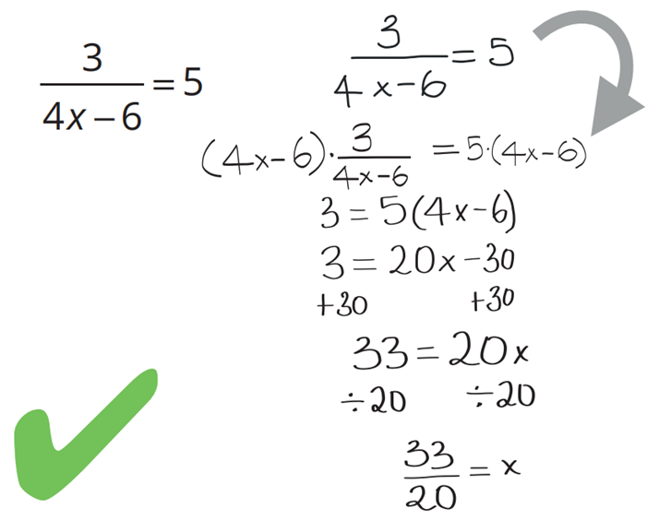  Maggie’s work: | In the step marked with an arrow, why did Maggie multiply both sides by $(4x - 6)$?  $4x-6$ is the ……………… of the fraction.  Solve:  $$\frac{6}{6x-4}=3$$  $$x=1$$

- Solve these equations.
- $\frac{4}{x}+\frac{5}{x}$ $=1$  9 | - $\frac{7}{y}+\frac{11}{y}$ $=2$  9 | - $\frac{21}{x}+\frac{19}{x}$ $=5$  8 | - $\frac{3}{2z}+\frac{19}{2z}$ $=5$  $$\frac{11}{5}$$
- $\frac{4}{x}+\frac{5}{2x}$ $=1$  $$\frac{13}{2}$$ | - $\frac{7}{3y}+\frac{11}{y}$ $=2$  $$\frac{20}{3}$$ | - $\frac{21}{2x}+\frac{19}{x}$ $=5$  $$\frac{59}{10}$$ | - $\frac{3}{4z}+\frac{19}{2z}$ $=5$  $$\frac{41}{20}$$

Development
- Solve these equations.
- $\frac{20+a}{a}$ $=-3$  $$-5$$ | - $\frac{9-2t}{t}$ $=13$  $$\frac{3}{5}$$ | - $\frac{3}{x-1}$ $=-1$  $$-2$$
- $\frac{3x}{2x-1}$ $=-1$  $$\frac{1}{5}$$ | - $5=$ $\frac{x+1}{x+2}$  $$-\frac{9}{4}$$ | - $\frac{2x+3}{1-x}$ $=4$  $$\frac{1}{6}$$
- $\frac{2x}{3}+\frac{x-1}{4}$ $=2x-1$  $$\frac{9}{13}$$ | - $\frac{3}{x^{2}}-\frac{2}{x}=\frac{5}{x}$  $$\frac{3}{7}$$ | - $\frac{1-3x}{x^{2}}+\frac{2}{3x}$ $=$ $\frac{4}{x}$  $$\frac{3}{19}$$
- $\frac{4x+1}{3}-\frac{x-3}{6}=\frac{x+5}{6}$  $$0$$ | - $\frac{1}{x+2}-\frac{2}{x-3}=\frac{5}{(x+2)(x-3)}$  $$-12$$ | - $\frac{2}{x+4}-\frac{1}{x-1}=\frac{3}{(x+4)(x-1)}$  $$9$$

- Find the value of $a$ by simplifying the LHS of these equations.
$$\frac{a}{x-1}-\frac{2}{x+1}=\frac{4}{\left(x-1\right)\left(x+1\right)}$$  2 | $$\frac{3}{2x-1}+\frac{a}{x+1}=\frac{5x+2}{\left(2x-1\right)\left(x+1\right)}$$  1

Mastery
- Reciprocals are used in the study of electronics to calculate resistances in parallel circuits.
This formula finds the total resistance $R_{T}$ in a circuit, given two resistors $R_{1}$, $R_{2}$ in parallel.
$$\frac{1}{R_{T}}=\frac{1}{R_{1}}+\frac{1}{R_{2}}$$
Find $R_{T}$:
$$\frac{1}{R_{T}}=\frac{1}{8}+\frac{1}{8}$$  4 | $$\frac{1}{R_{T}}=\frac{1}{6}+\frac{1}{6}$$  3 | $$\frac{1}{R_{T}}=\frac{1}{6}+\frac{1}{4}$$  $$\frac{12}{5}$$ | $$\frac{1}{R_{T}}=\frac{1}{120}+\frac{1}{260}$$  $$\frac{1560}{19}$$

Show that this is always true: When two resistors with equal resistance are connected in parallel, the total resistance is equal to half the resistance of one of the resistors.
$$\frac{1}{R_{T}}=\frac{1}{x}+\frac{1}{x}$$
$$\frac{1}{R_{t}}=\frac{2}{x}$$
$$∴R_{T}=\frac{x}{2}$$
- One number is twice another number. The sum of their reciprocals is $\frac{3}{10}$.
  - Write an equation describing the situation.
  - Solve the equation to find the two numbers.

$$\frac{1}{2x}+\frac{1}{x}=\frac{3}{10}$$
$$x=5$$
The two numbers are 5 and 10
- Solve this equation.
$$\frac{7}{4}=1+\frac{1}{1+\frac{1}{x}}$$

3

